Contents

Pthon plot Command 2

HistPlot 2

box plot 2

BarGraph 2

Lineplot 3

ScatterPlot 3

JointPlot 3

Violin Plot 3

StrippPlot 3

CatPlot 4

PairPlot 4

HeatMap 4

Plotty 4

Hypothesis Testing Framework 5

Vector Machine 6

FeatureSelectionAndModelingWeek1 9

FeatureSelectionAndModelingWeek2 12

Introduction to SQL 18

Numerical Feature 18

String functions 18

Date Functions 19

Aggregation Function 20

Pre Work Deep Learning 23

Linear Algebra 23

Activation Function 23

# Pthon plot Command

HistPlot --sns.histplot(data=df, x='price')

sns.histplot(data=df, x='price', bins=5)

sns.histplot(data=df, x='price', binwidth=20)

sns.histplot(data=df, x='price', kde=True);

sns.histplot(data=df, x='price', hue='body_style', kde=True);

SubPlot -g = sns.FacetGrid(df, col="body_style")

g.map(sns.histplot, "price");

box plot -sns.boxplot(data=df, x='curb_weight');

sns.boxplot(data=df, x='body_style', y='price') ;

BarGraph -sns.countplot(data=df, x='body_style');

sns.countplot(data=df, x='body_style', hue='fuel_type');

sns.countplot(data=df, x='make');

plt.figure(figsize=(20,7))

sns.countplot(data=df, x='make')

plt.xticks(rotation=90)

plt.show() # this will ensure that the plot is displayed without the text

Cusomizing Histogram: plt.title('Histogram: Price')

plt.xlim(3000,50000)

plt.ylim(0,70)

plt.xlabel('Price of cars')

plt.ylabel('Frequency')

sns.histplot(data=df, x='price', color='orange');

Lineplot : sns.lineplot(data = flights , x = 'month' , y = 'passengers');

sns.lineplot(data=flights , x='month' , y='passengers', ci=False);

sns.lineplot(data = flights , x = 'month' , y = 'passengers', hue = 'year')

ScatterPlot : sns.scatterplot(data=df, x='engine_size', y='horsepower');

sns.scatterplot(data=df, x='engine_size', y='horsepower', hue='fuel_type');

sns.scatterplot(data=df, x='engine_size', y='horsepower', hue='fuel_type', style='fuel_type');

lmplot : sns.lmplot(data=df, x='curb_weight', y='horsepower');

sns.lmplot(data=df, x='curb_weight', y='horsepower', hue='fuel_type',ci=False);

sns.lmplot(data=df, x='curb_weight', y='engine_size', col='number_of_doors', ci=False)

JointPlot : sns.jointplot(data=df, x='engine_size', y='horsepower');

sns.jointplot(data=df, x='engine_size', y='horsepower', kind="hex");

sns.jointplot(data=df, x='engine_size', y='horsepower', kind="kde", fill=True);

sns.jointplot(data=df, x='price', y='city_mpg', kind="reg");

Violin Plot : sns.violinplot(data=df, x='horsepower');

sns.violinplot(data=df, x='fuel_type', y='horsepower', orient='v');

sns.violinplot(data=df, x='body_style', y='engine_size', palette="bright");

StrippPlot : sns.stripplot(data=df, x='engine_size');

sns.stripplot(data=df, x='body_style', y='engine_size');

sns.stripplot(data=df, x='body_style', y='engine_size');

sns.stripplot(data=df, x='number_of_doors', y='horsepower', jitter=True);

SwarmPlot ; sns.swarmplot(data=df, x='number_of_doors', y='price');

sns.swarmplot(data=df, x='fuel_type', y='price', hue='number_of_doors');

sns.swarmplot(data=df, x='fuel_type', y='price', hue='number_of_doors', dodge=True);

CatPlot : sns.catplot(data=df, x='fuel_type', y='horsepower');

sns.catplot(data=df, x='body_style', y='horsepower', hue='fuel_type', kind='point');

sns.catplot(data=df, x="fuel_type", y="horsepower", hue="number_of_doors", col="drive_wheels", kind='bar', palette='pastel');

sns.catplot(data=df, x="number_of_doors", y="price", hue="body_style", col="fuel_type", kind='swarm', palette='muted');

PairPlot : sns.catplot(data=df, x="number_of_doors", y="price", hue="body_style", col="fuel_type", kind='swarm', palette='muted');

sns.pairplot(data=df, vars=['wheel_base', 'curb_weight', 'engine_size', 'price'], hue='number_of_doors');

sns.pairplot(data=df, vars=['wheel_base', 'curb_weight', 'engine_size', 'price'], corner=True);

HeatMap : sns.heatmap(data=df[['wheel_base','curb_weight','engine_size','price']].corr());

sns.heatmap(data=df[['wheel_base','curb_weight','engine_size','price']].corr(), annot=True, cbar=False);

sns.heatmap(data=df[['wheel_base','curb_weight','engine_size','price']].corr(), annot=True, cmap='YlGnBu');

Plotty : import plotly.express as px

his = px.histogram(df, x="price")

his.show()

bar = px.bar(df, x='peak_rpm', y='horsepower')

bar.show()

scat = px.scatter(df, x='price', y='engine_size')

scat.show()

fig = px.box(df, x="fuel_type", y="horsepower", points="all")

fig.show()

3d Scatter plot :fig_3d = px.scatter_3d(df, x='fuel_type', y='horsepower', z='price', color='horsepower')

fig_3d.show()

# Hypothesis Testing Framework

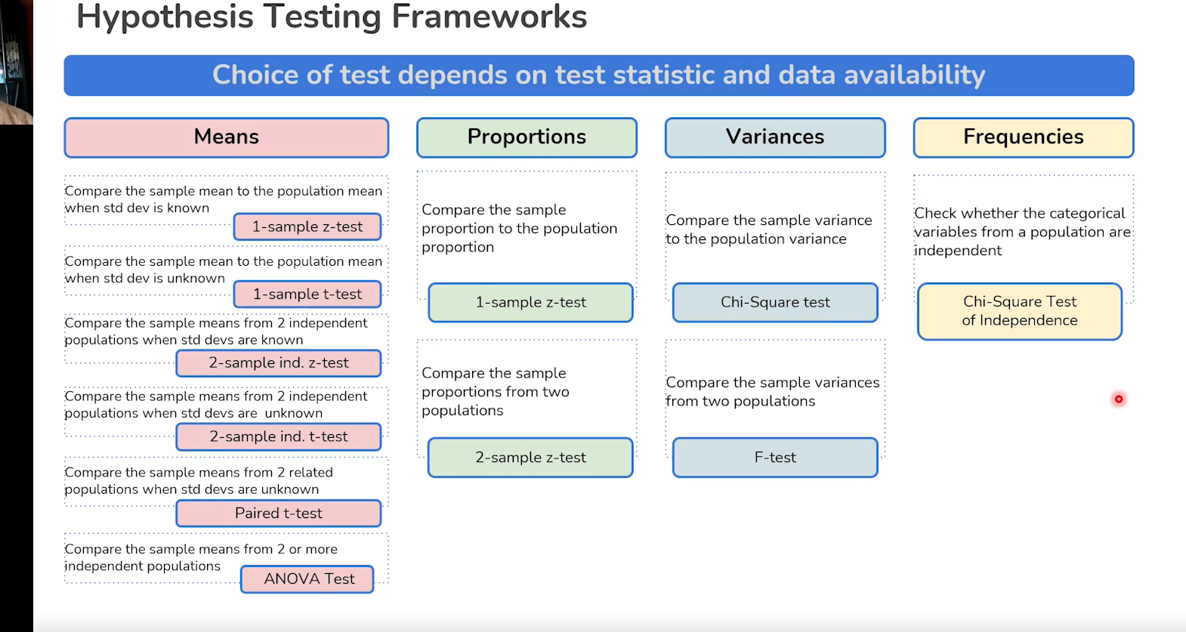

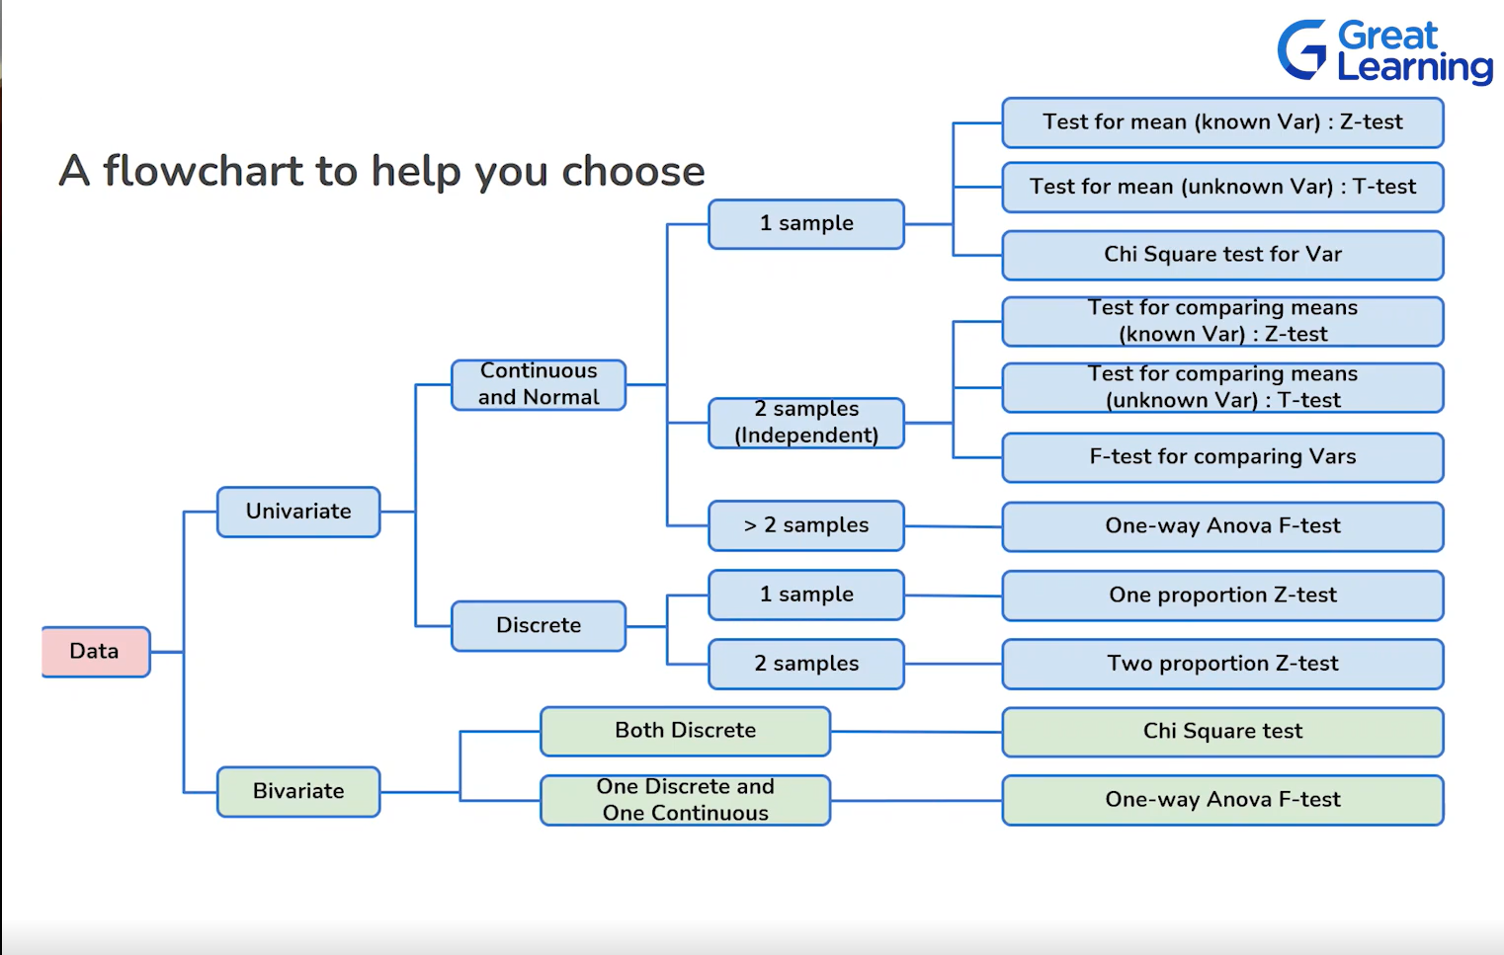

# Vector Machine

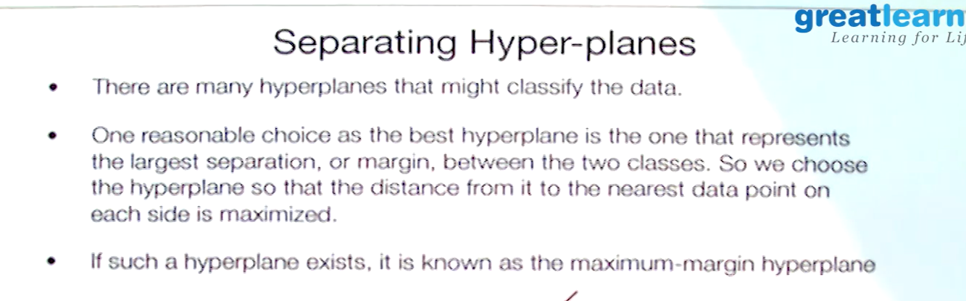

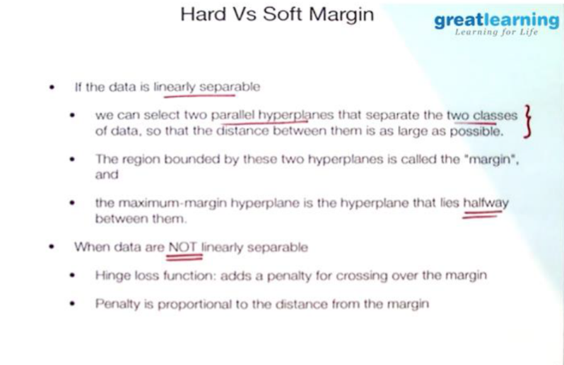

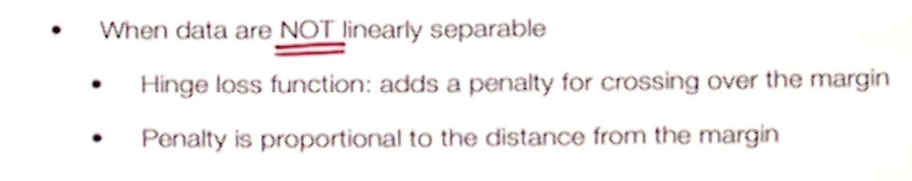

-- Data that is not seperable

We will still select the plane that has largest margin --but

we need to add some penality for crossing over the margin --

Min= I/margin + lembda times Sum penalty

Penalty will be zero for point not crossing over

Common panalty -- hinge loss

0 - if no viiolation

Proportion to distance for crossing over points

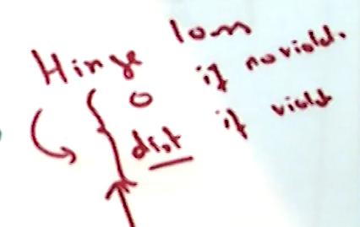

If data is not separable we can create a new variable

In 1D ..data is not separable but if we visualize on 2-D by using some nonlinear function and create new variable using kernel

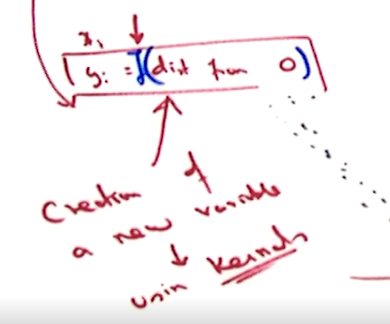

Kernel -- is basically a nonlinear function used to create new variables

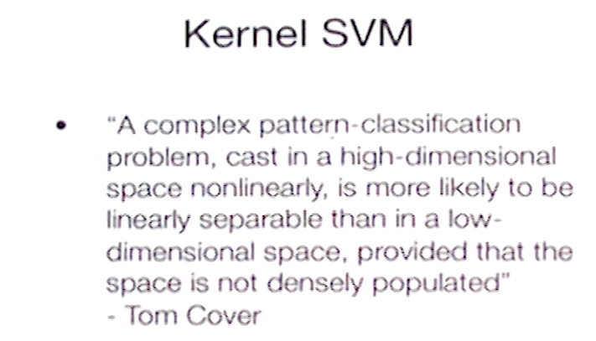

# FeatureSelectionAndModelingWeek1

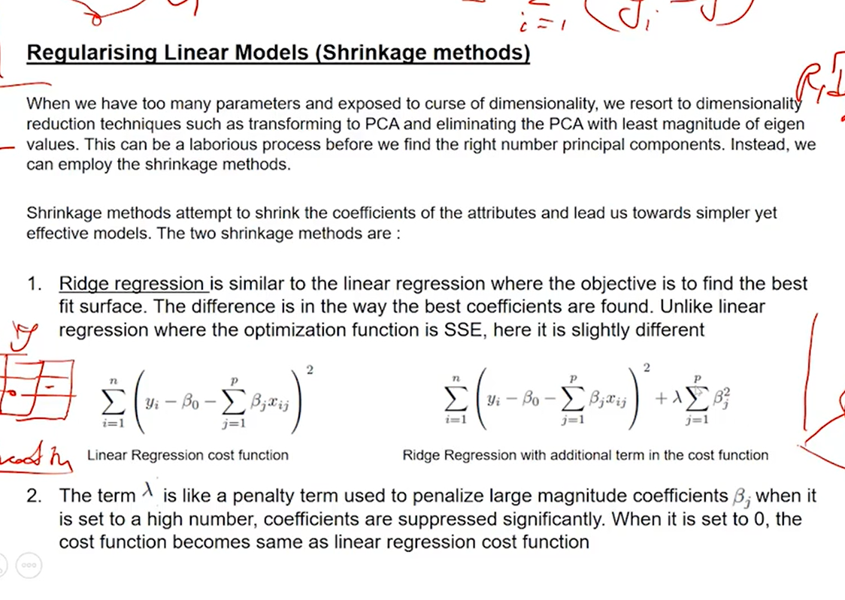

When model is performing too well in Training set but poorly in test set -- Overfit

When model is performing bad in training and test set both --underfit

If performs equally well in training and test set ==right fit zone

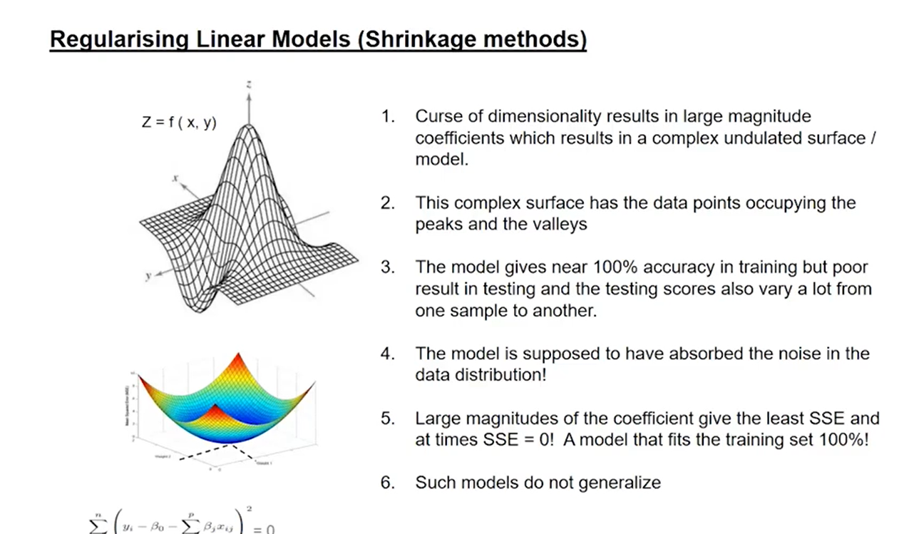

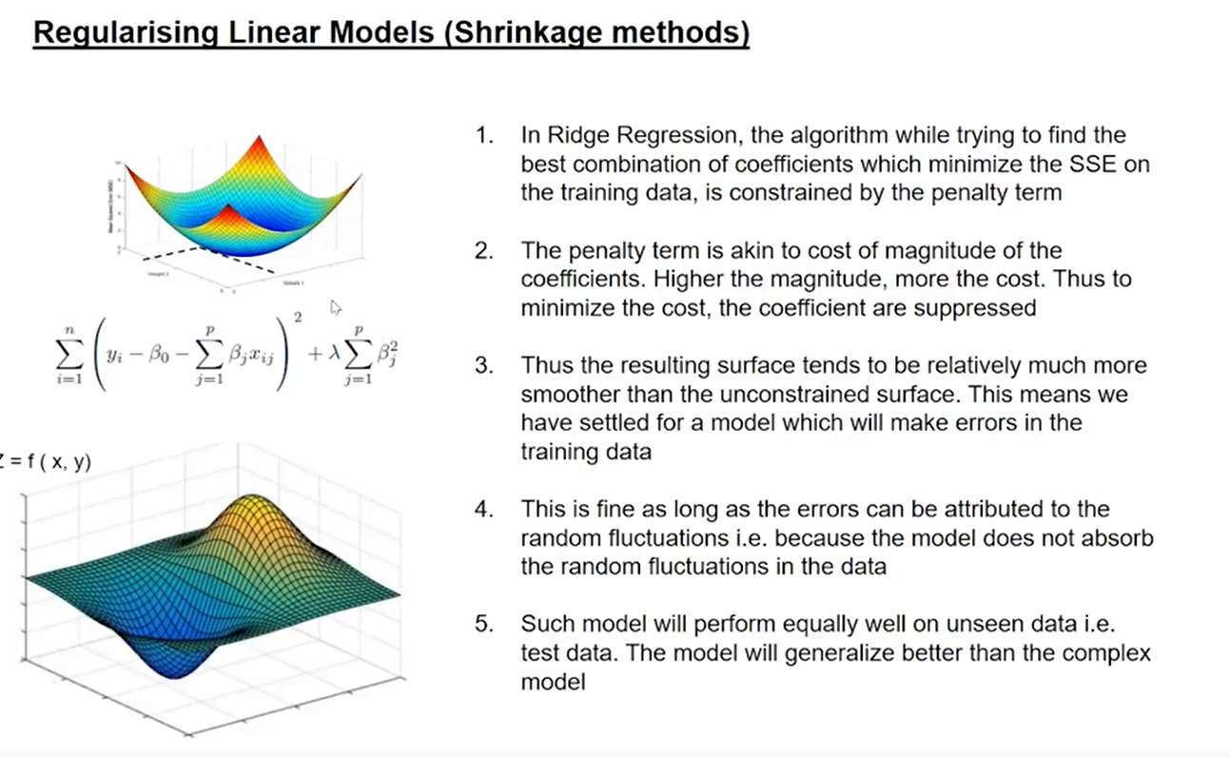

In Ridge regression the algorithm tries to penalizes coefficient with high

Magnitude and push them towards value zero but never make it 0

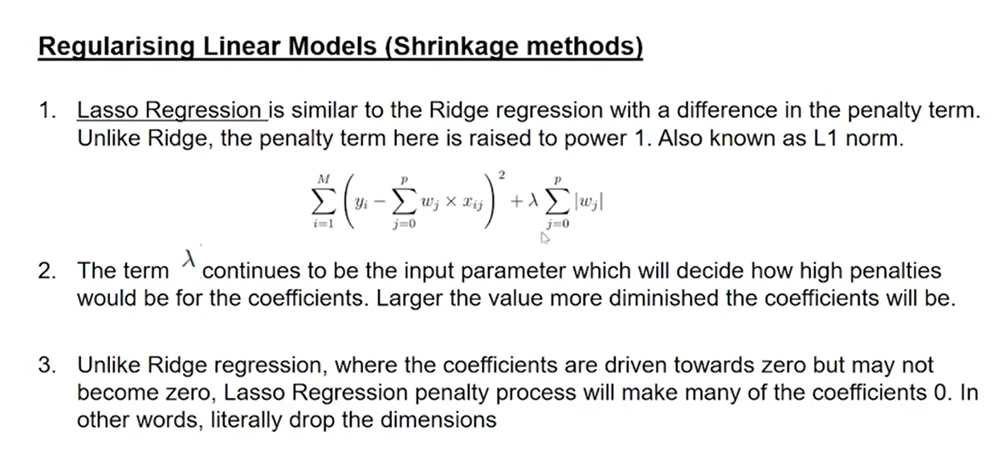

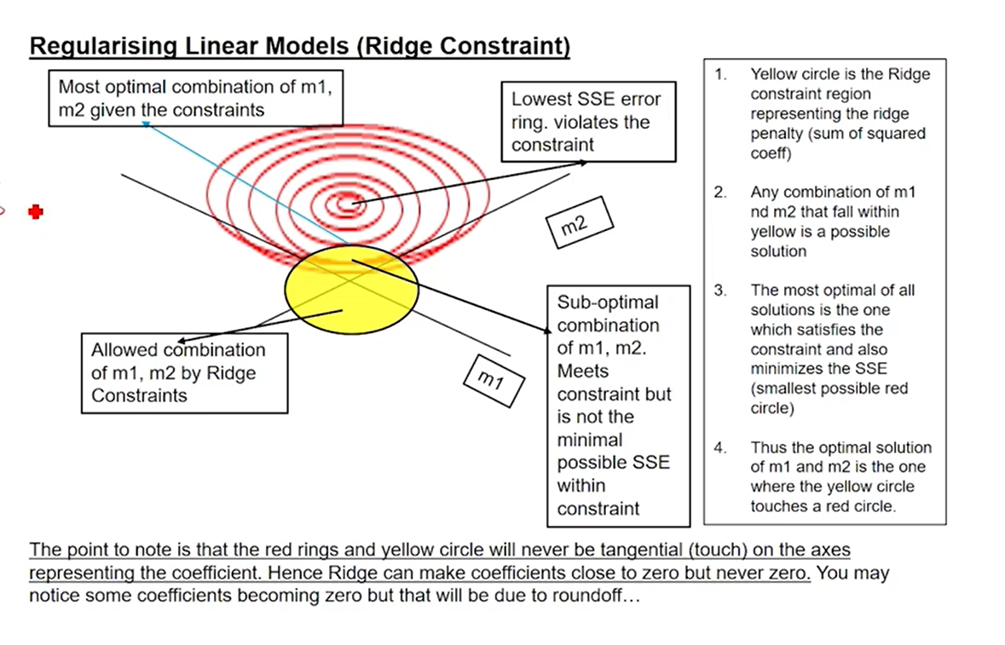

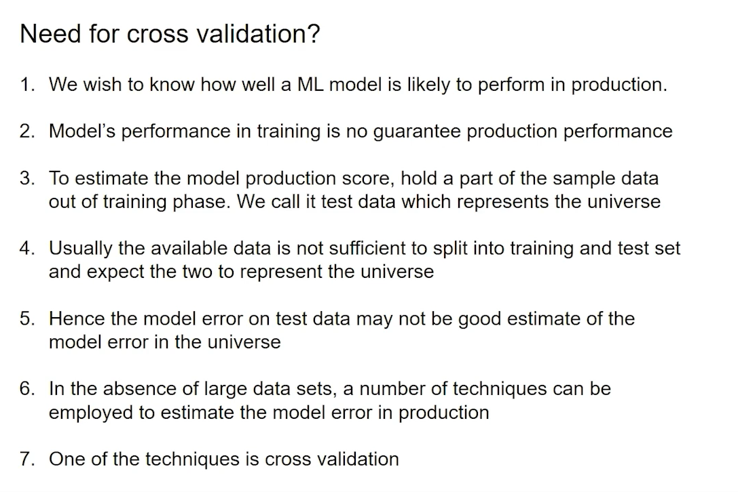

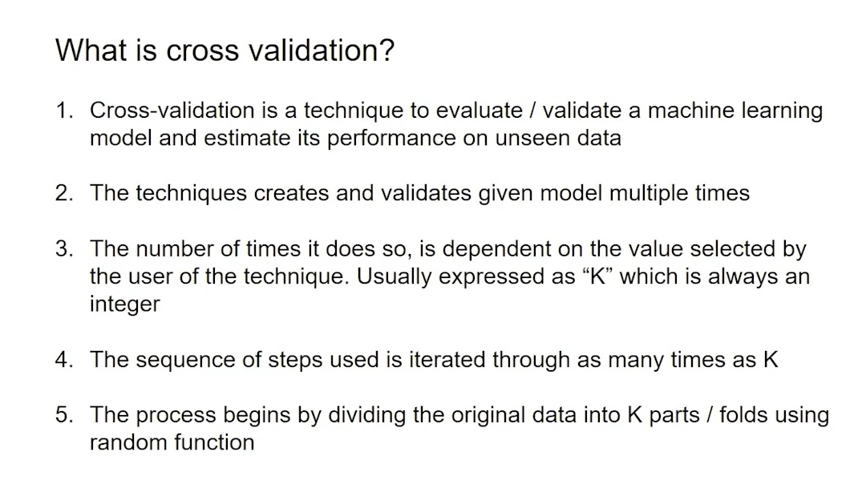

# FeatureSelectionAndModelingWeek2

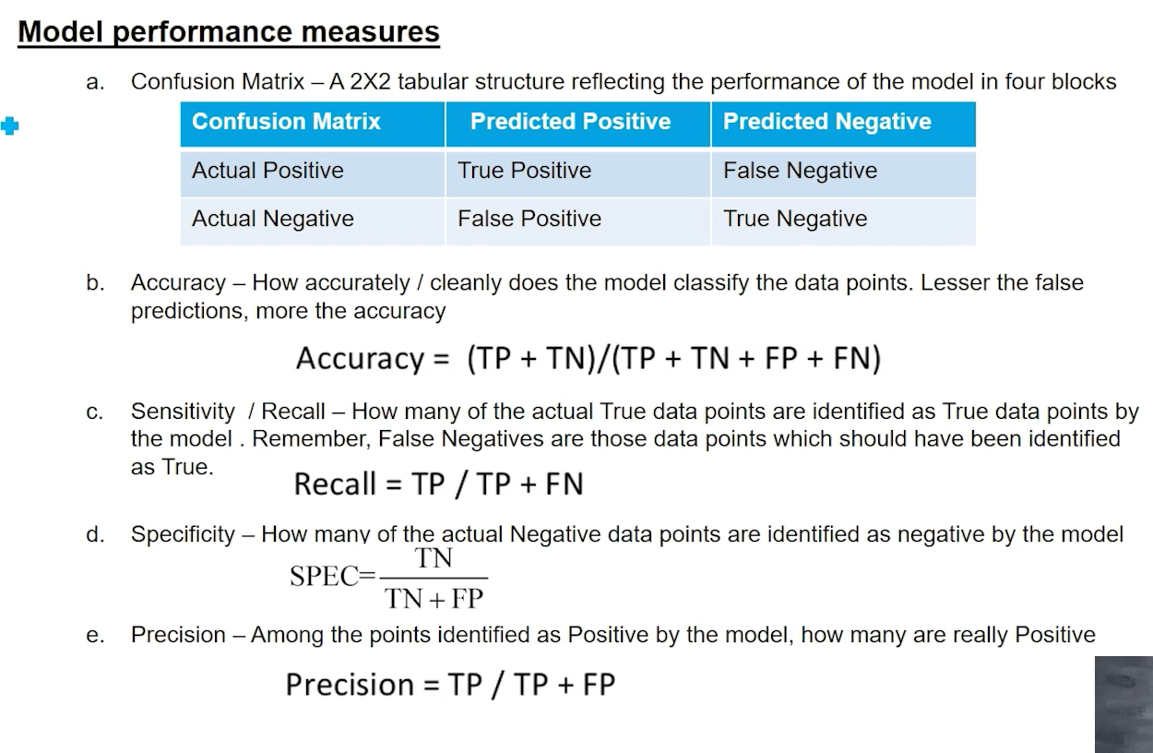

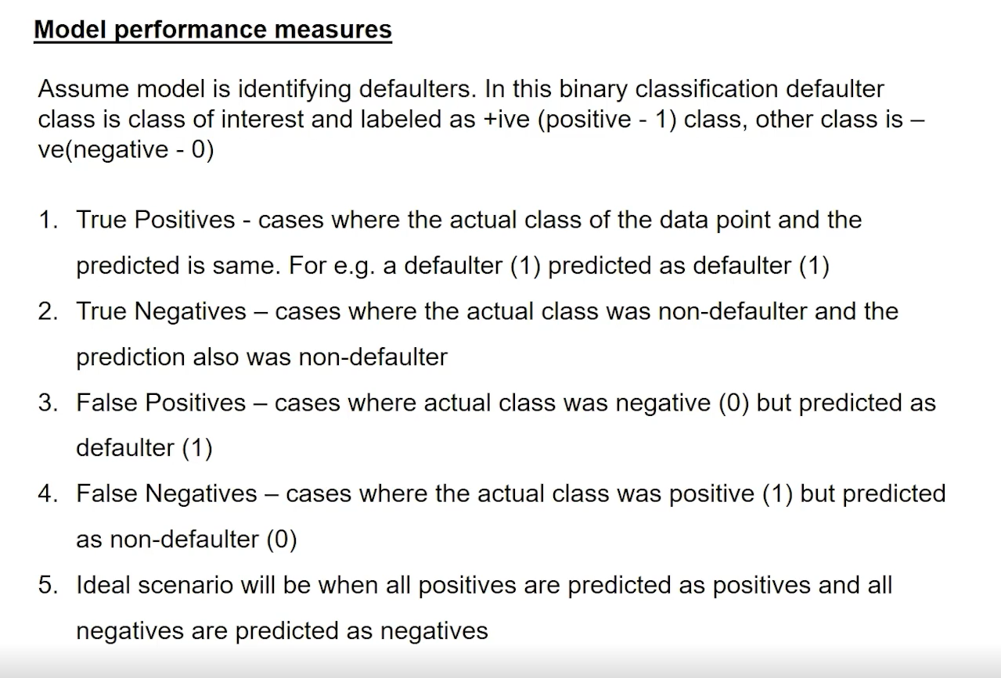

F1 Score == 2 (P* Rl)(P+R)

P - Precision

R-Recall

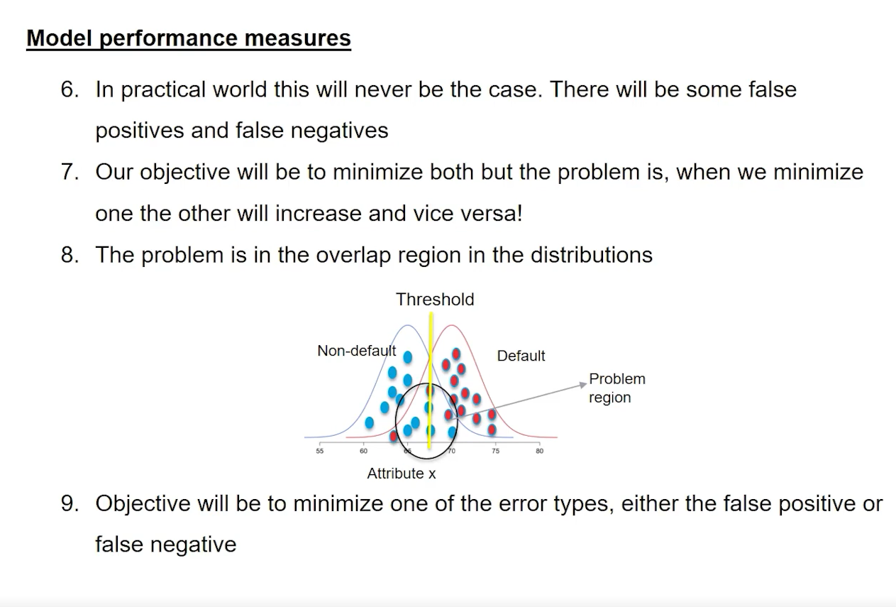

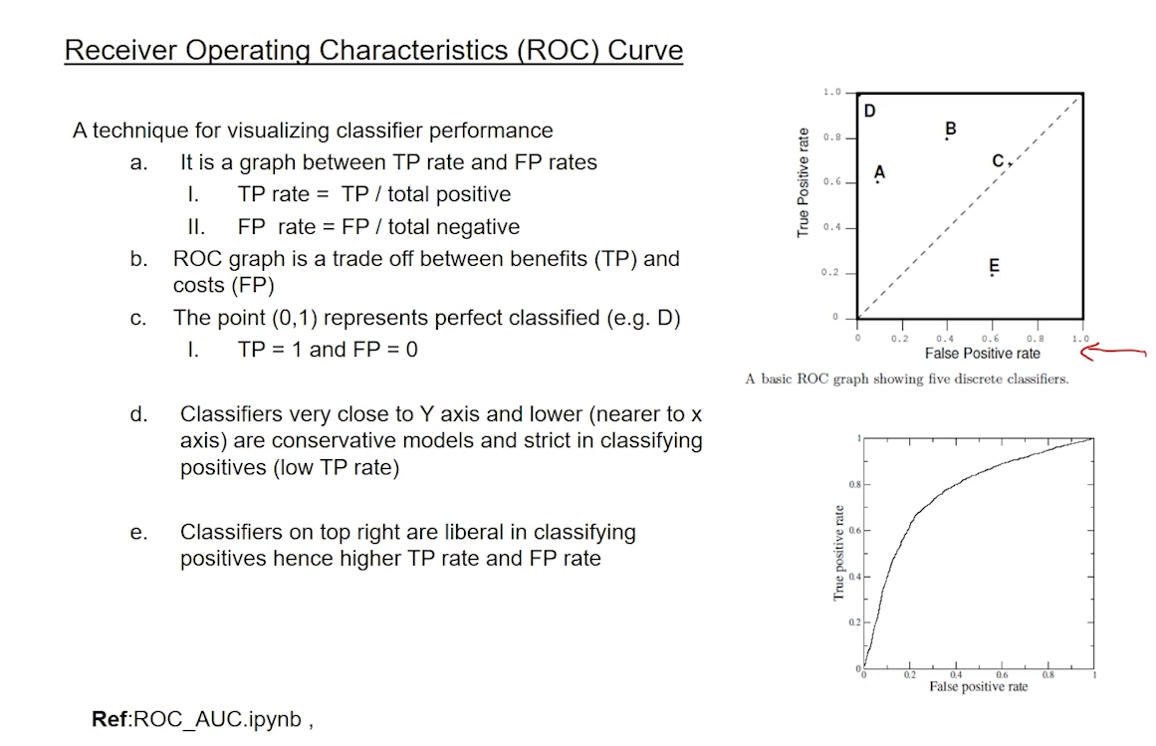

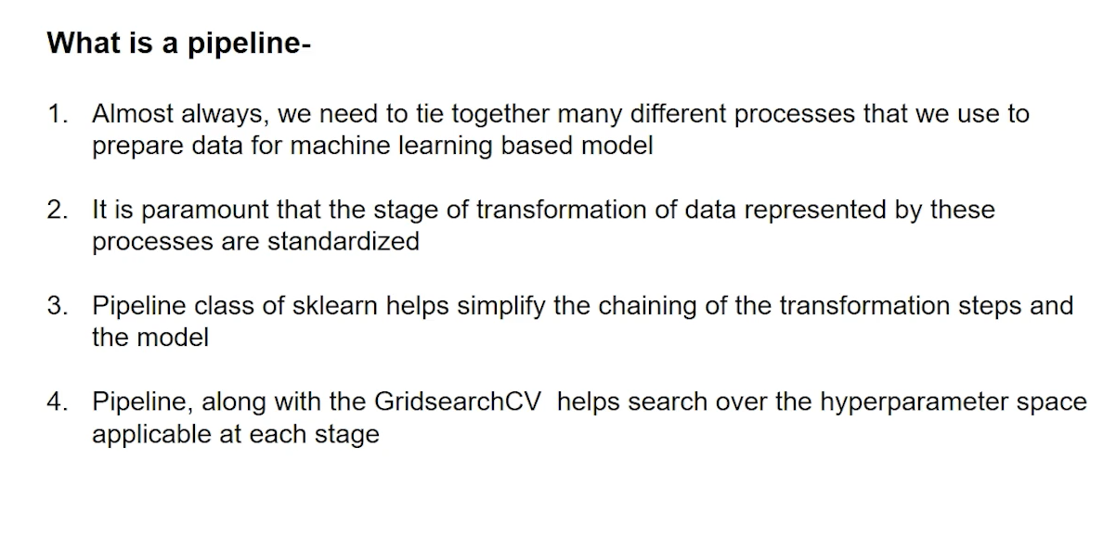

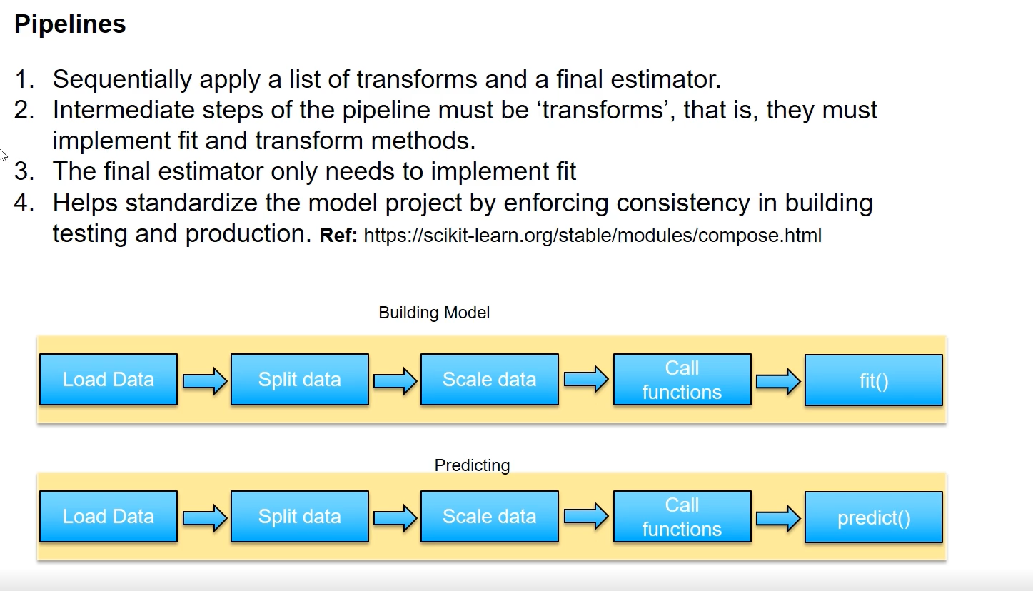

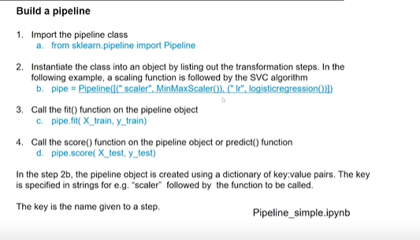

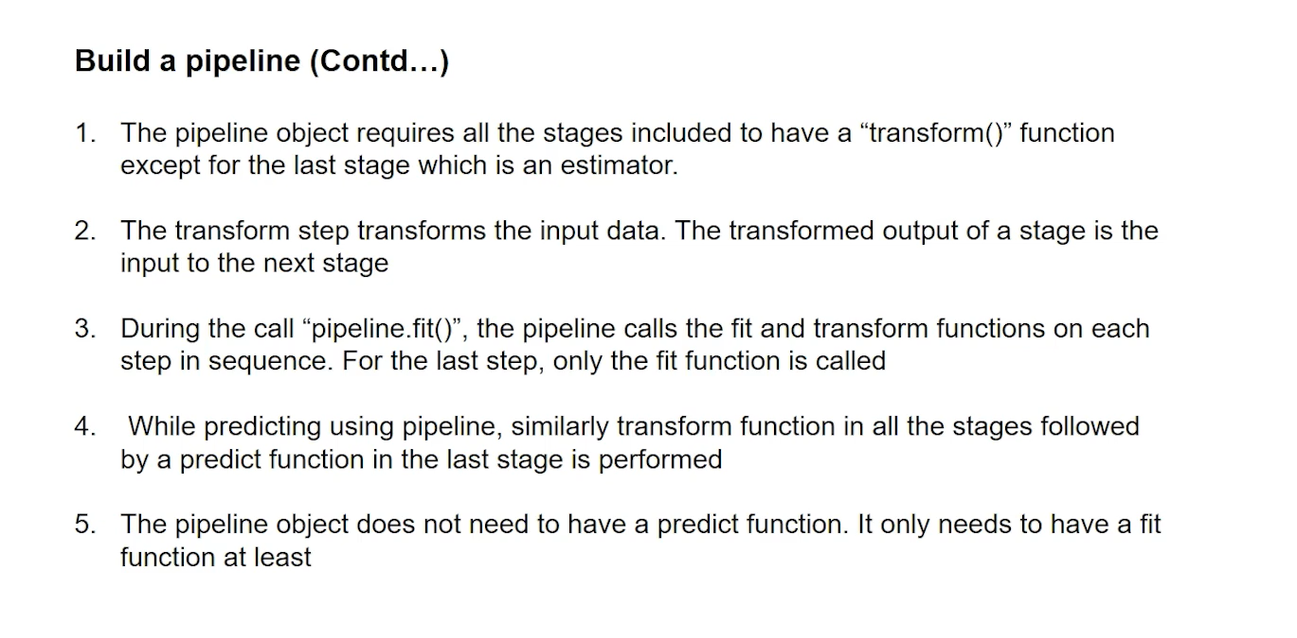

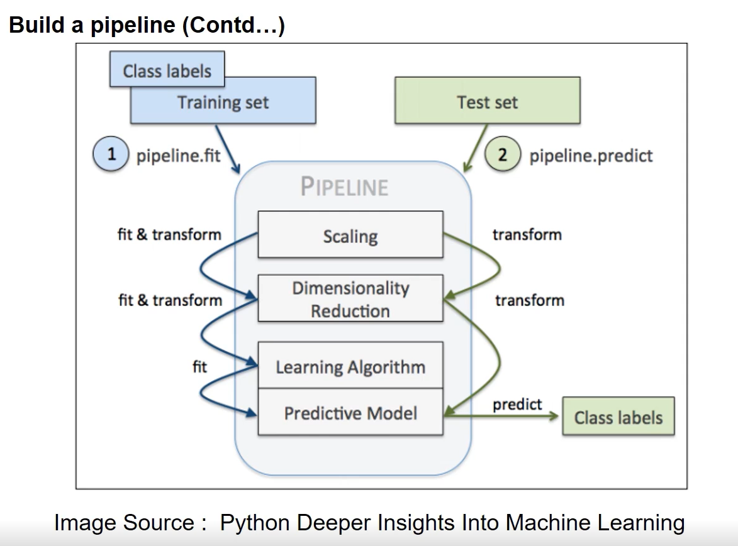

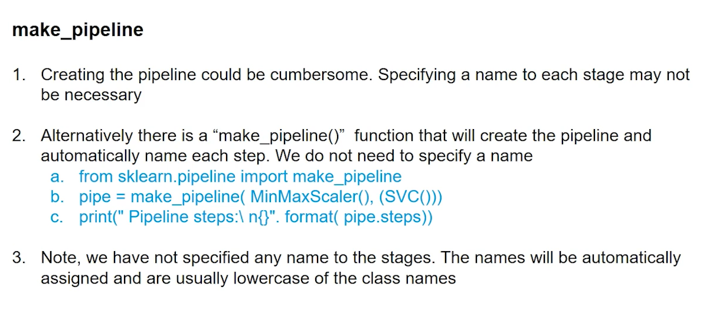

Important : Divide your model in to training ,validation and test –to ensure that you use validation data to tweak your model and to ensure performance improvement and you only expose model to test data once we finalize the model to see if model is overfit and underfit

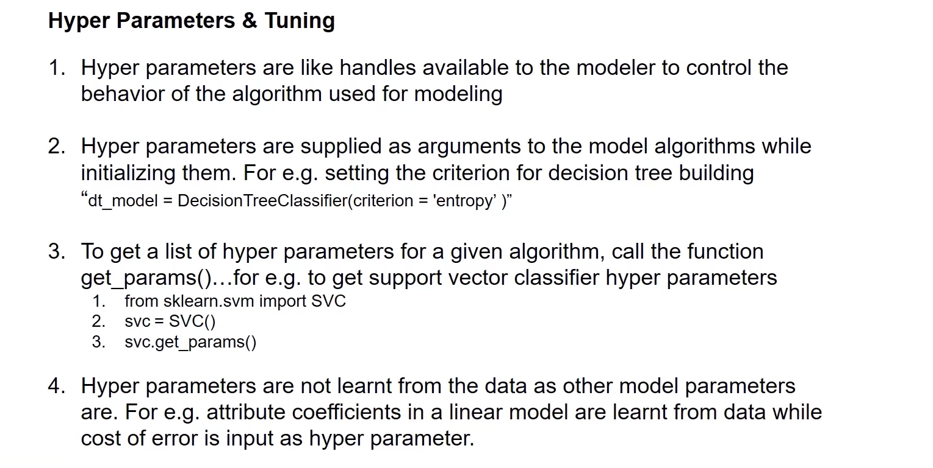

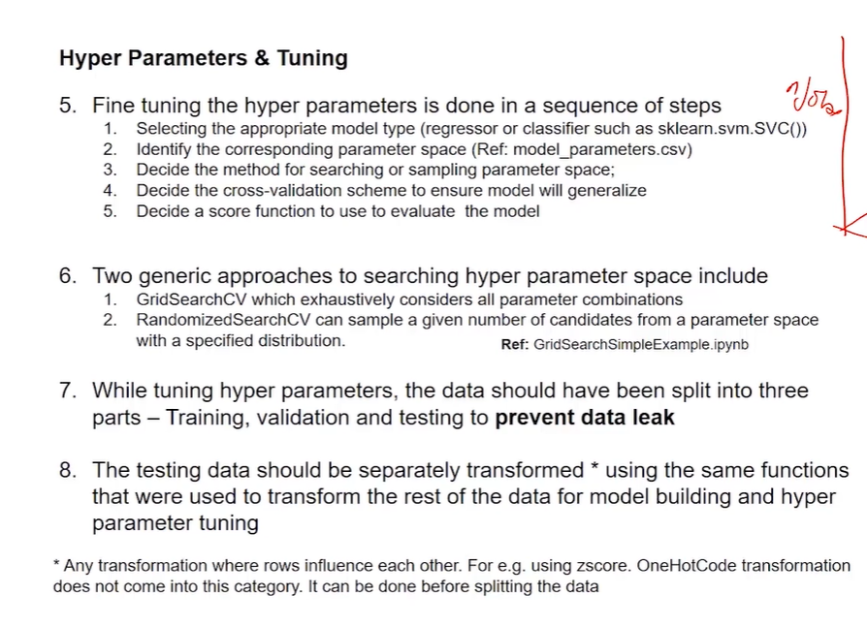

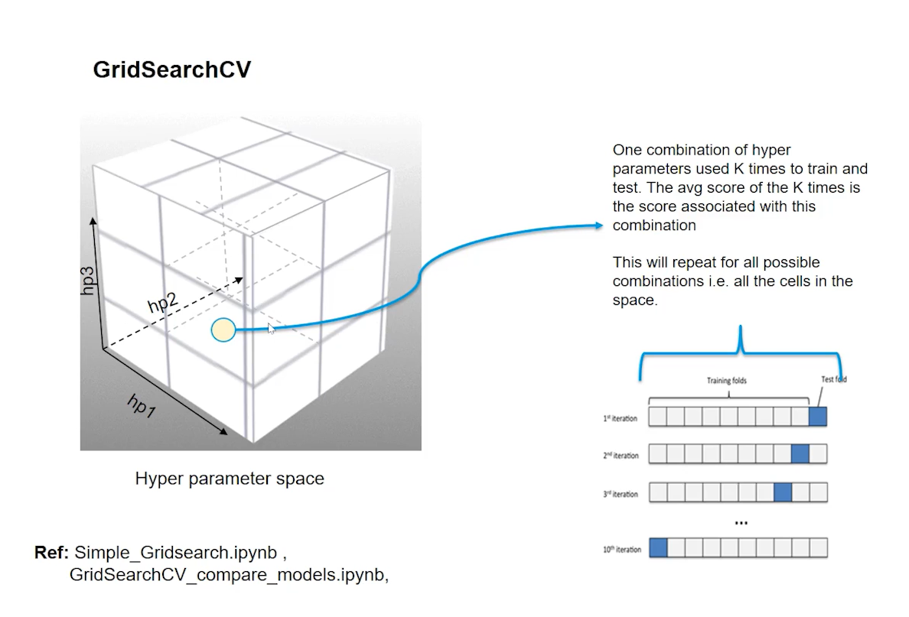

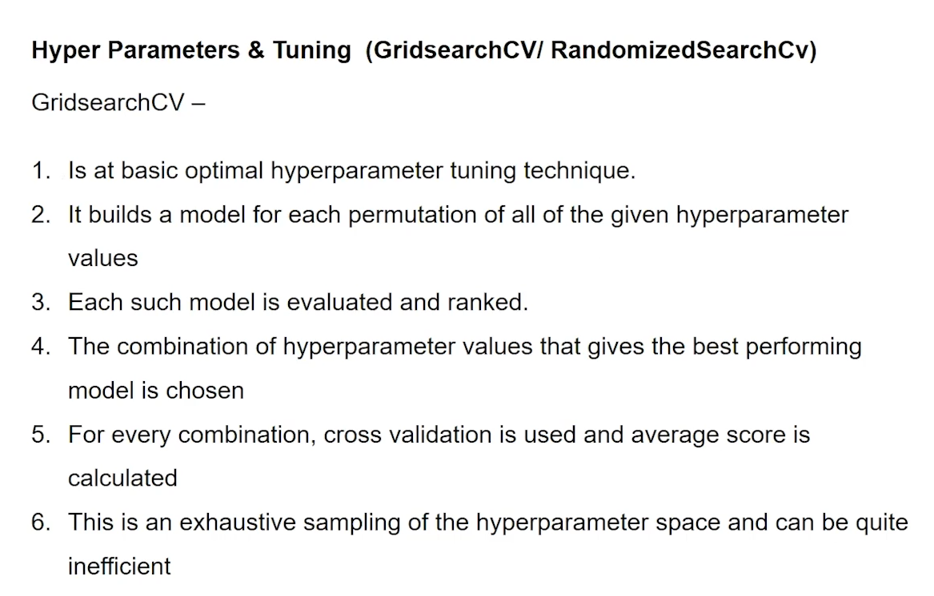

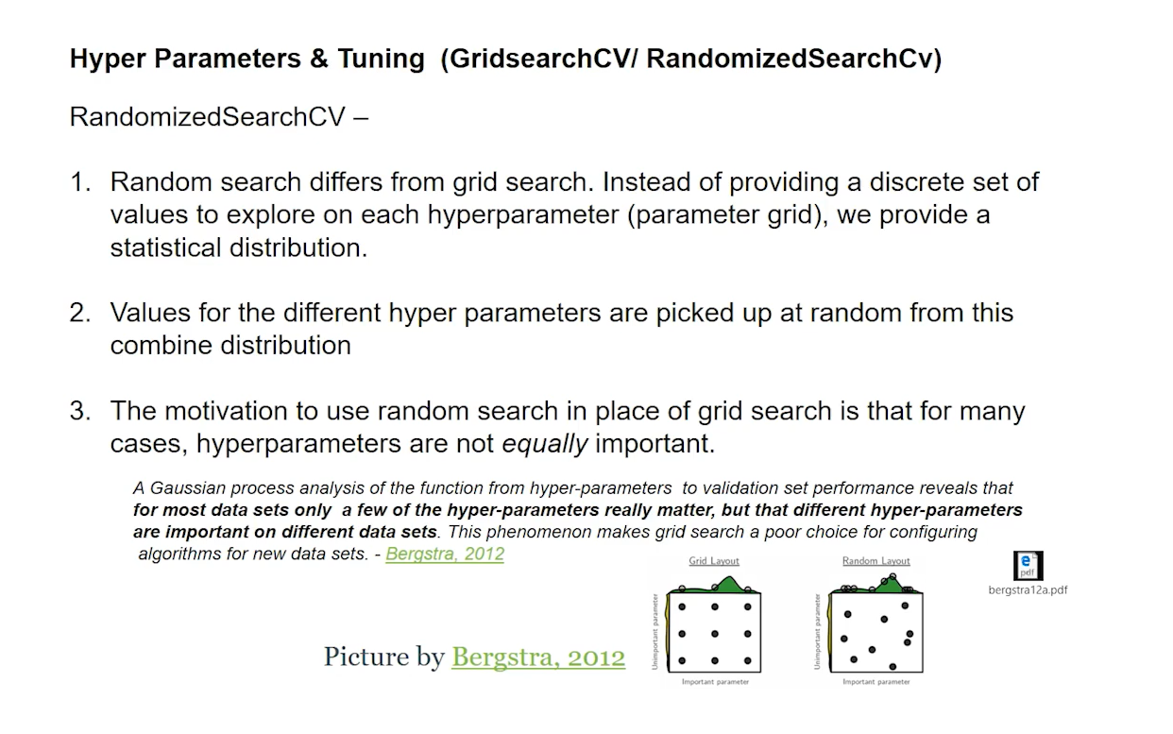

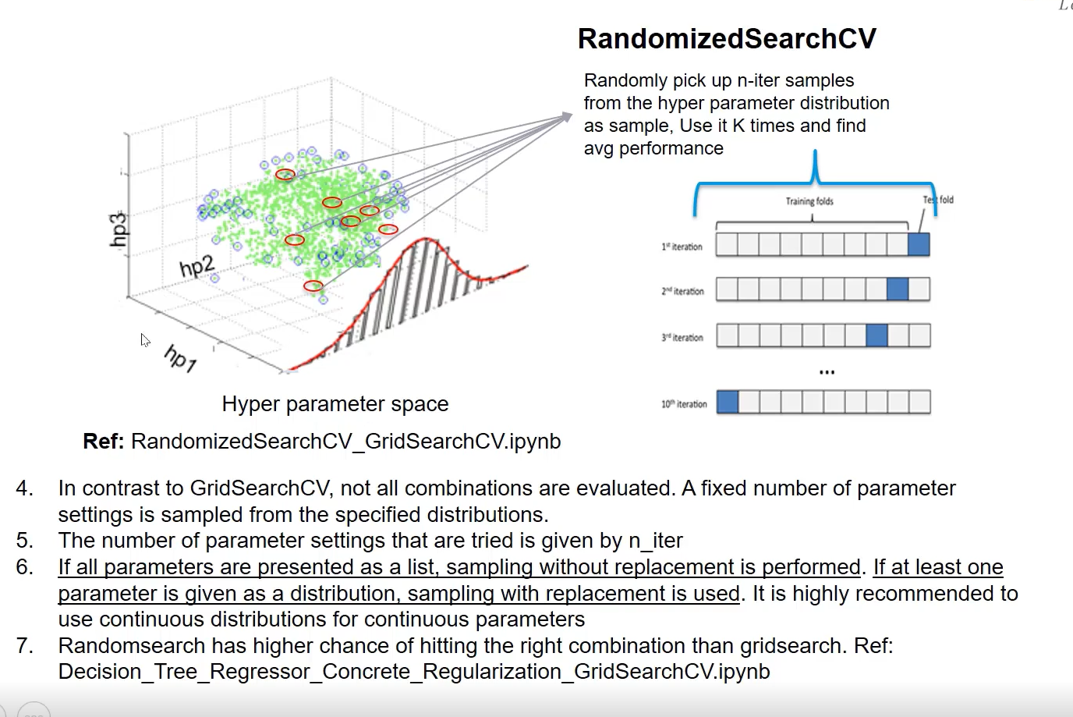

# Introduction to SQL

### Numerical Feature

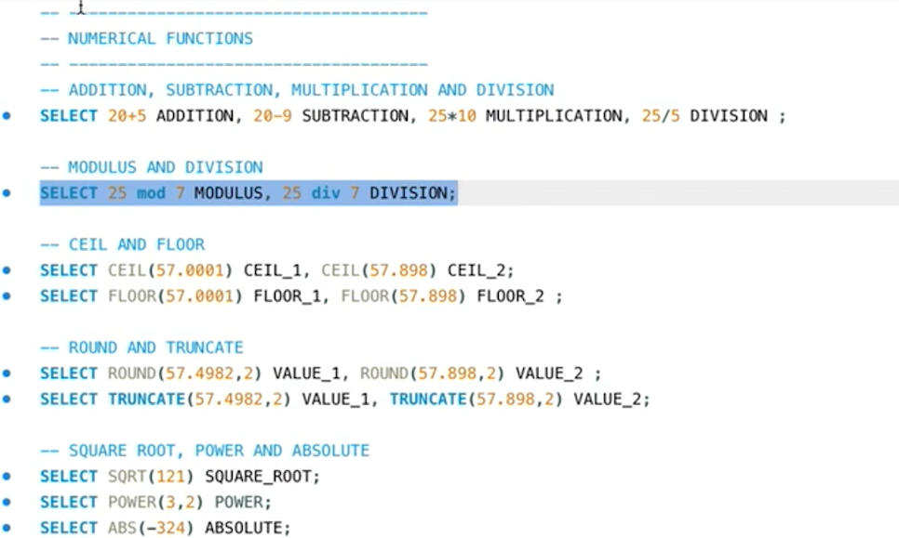

Truncate just truncated the digits while round will roundoff

57.49882,2 –round to 57.50

While it will be truncated if 57.49

### String functions

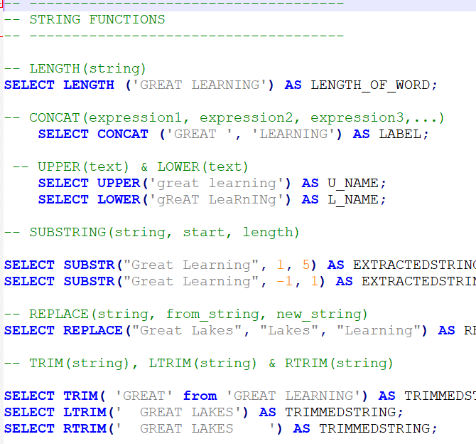

## Date Functions

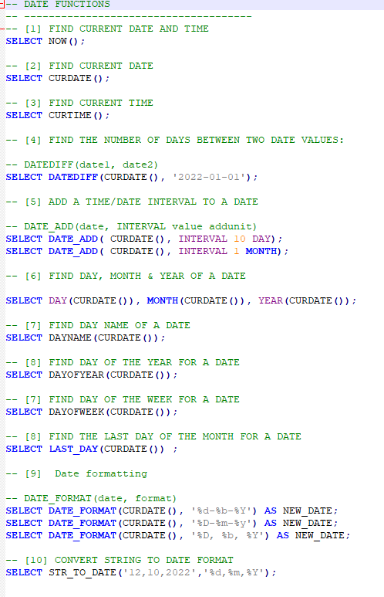

## Aggregation Function

Data

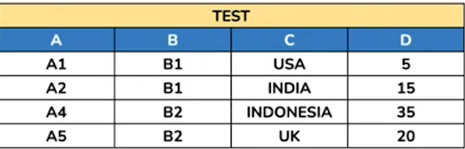

Sum + groupBy

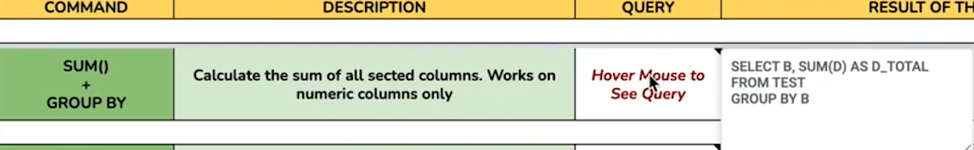

Output

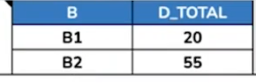

Avg()+groupby



Output

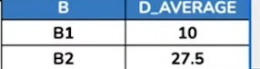.

MIN()+groupby



Output

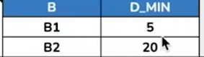

Max+groupby



Output

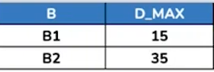

Count all rows of a table







Output

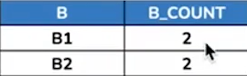

Sort the data

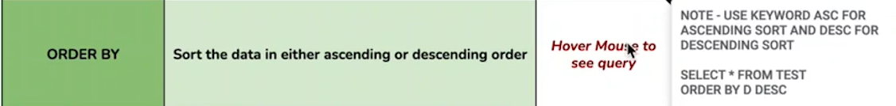

Output

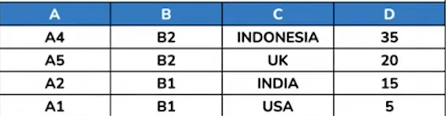

Case when

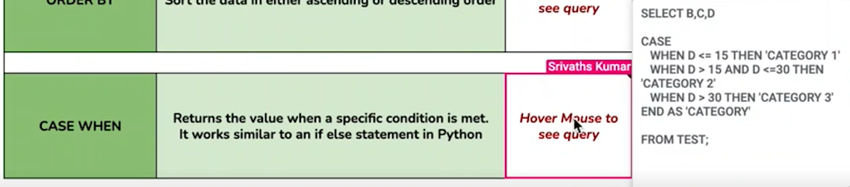

Output

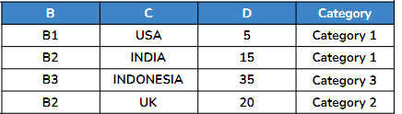

Summary

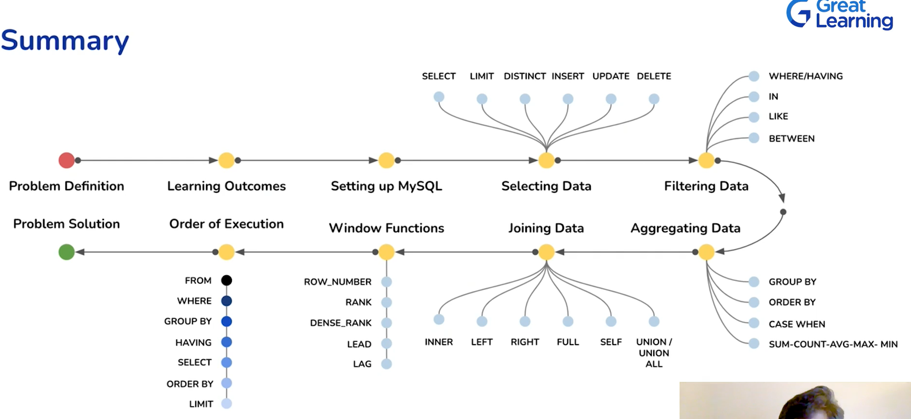

# Pre Work Deep Learning

## Linear Algebra

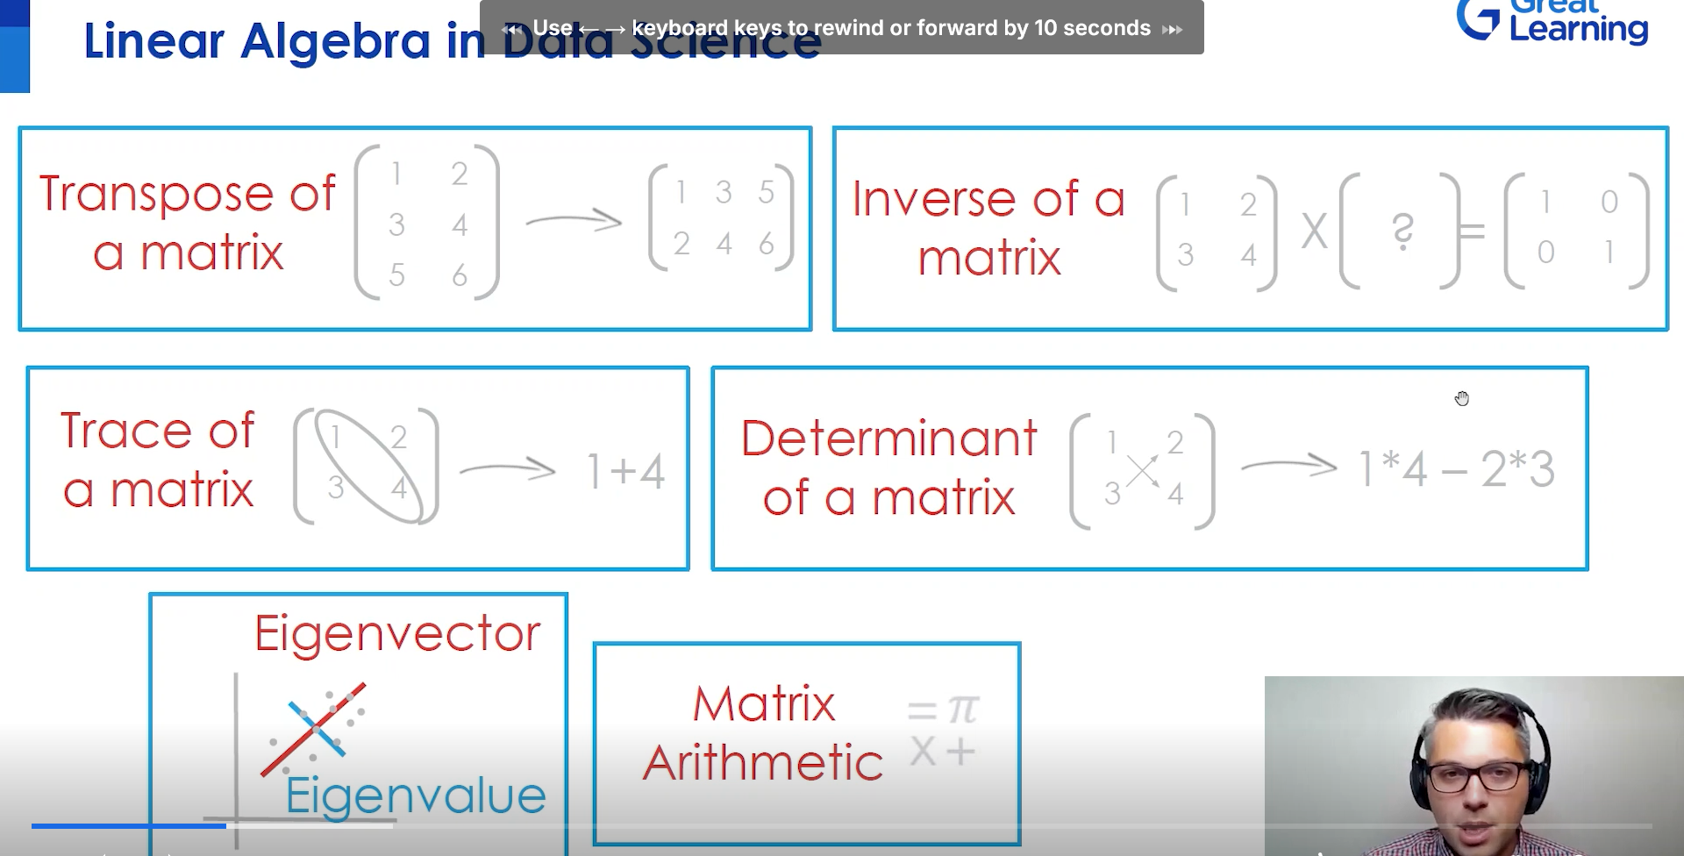

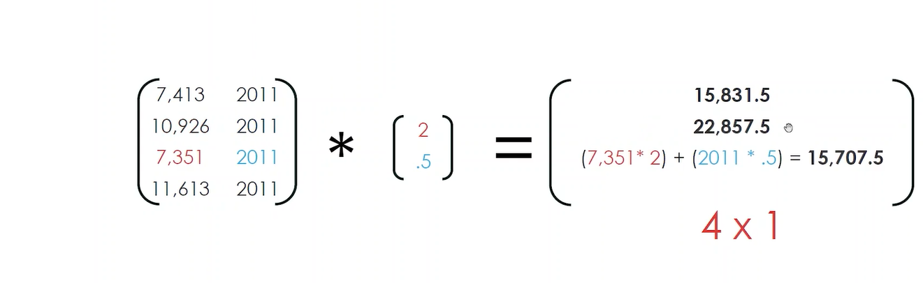

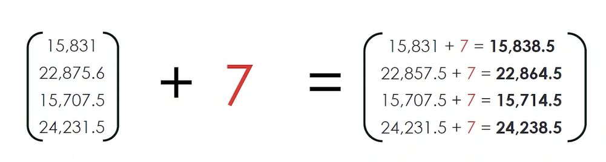

## Activation Function

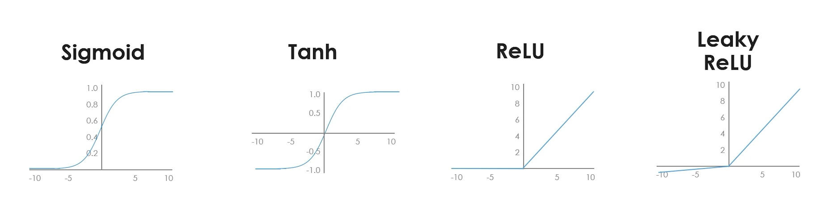

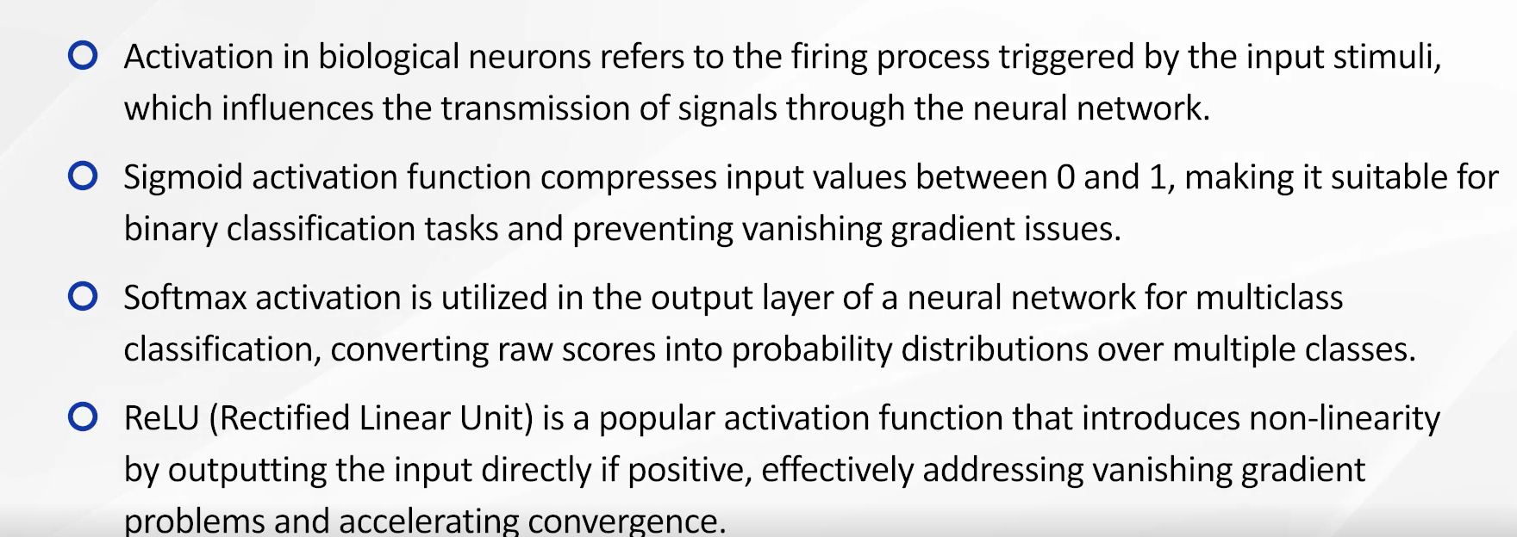

## Gradient Descent

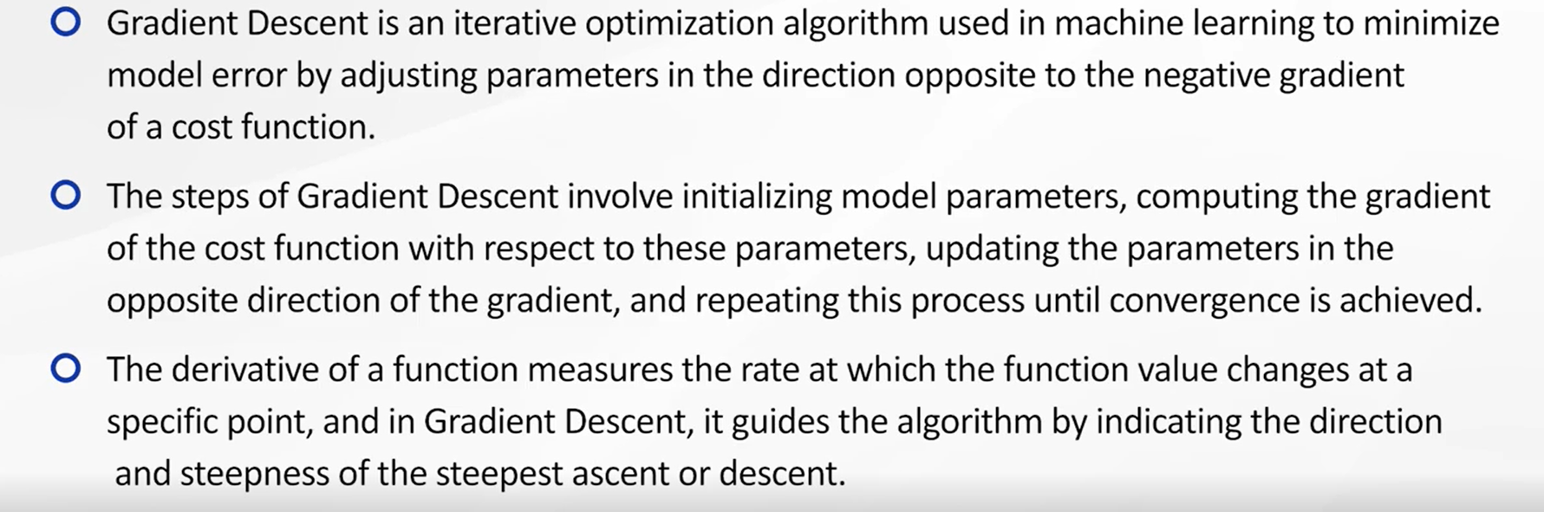

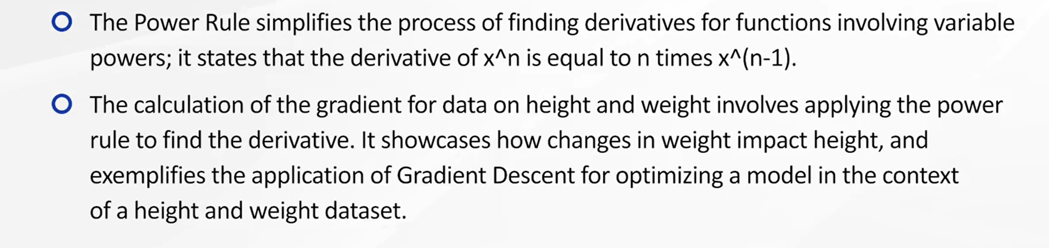

## Optimizer in Gradient Descent

